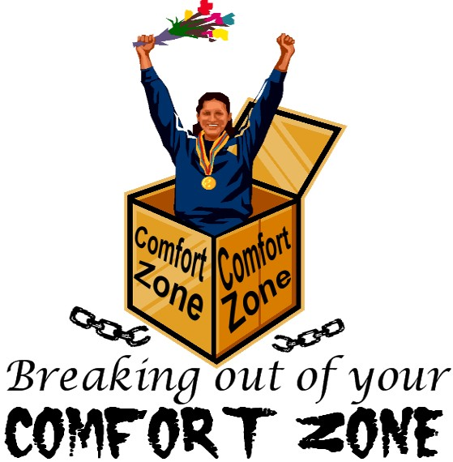
Jeopardy Challenge
- Developing Questioning Skills

Instructions:
This activity is similar to Trivia, but it is in reverse. Instead of questions given to students, Answers are given, and the students need to form the correct question. Contestants/Students are to line up shoulder to shoulder in front of a desk, facing the facilitator. (5 Students per event) When an answer is shown to the group, the first one to hit the table and forms the correct question wins. But the question must be formed before he hits the table, not afterwards. Facilitators are to randomly choose answers from the following categories.

Example:
Answer: BEIJING Question: What is the Capital of China?
=================================+=================================

Moon  Cow  Microphone  Mosquito  Lunch  Shirt  Television  QQ Car  Subway Station  Bridge  Elephant  Ocean | People:  Qin ShiHuang  Bill Gates  George Washington  Cao XueQin  Neil Armstrong  Liu Xiang  Wen JiaBao  Thomas Edison  Lao She  Ba Jin  Moses

Places:  Great Wall  The White House  London  Hiroshima  Everest  Sahara Desert  San Xia Dam  Vatican City  Jerusalem  Pluto | Misc:  100 degrees  Euro  Giraffe  MP3  299,792,458 m/s  H20  3.1415  365
Dates:
2008

1949
October 1st

December 25

1921
May 1st

Sept 10th

1997-7-1
June 1st

