Opposites
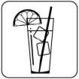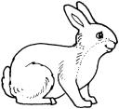
SIZE SIZE 7:00am 8:00pm
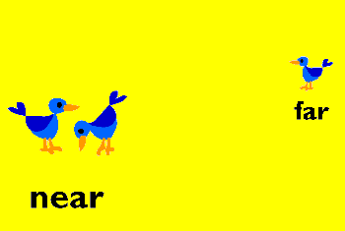

_______________ $250,000 $3 ************ ***
__________
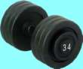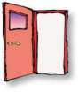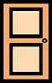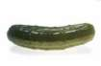


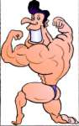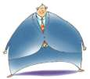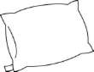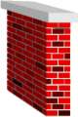

Hot, Cold, Slow, Fast, Pretty, Ugly, Big, Small, Early, Late, Near, Far, Full, Half, Long Short, Expensive, Cheap, Many, Few, Heavy, Lite, Open, Close, spicy, Mild, Good, Bad, Up Down, Old, Young, Bald, Harry, weak, strong, Fat, Thin, soft, hard.

