Phonetic Chart

hot -   sit -   tell -   man - 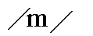  nut -   dig -   king -   lit -   but -   fig -   yes -   just - 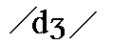  shut -   think -   other -   vision - 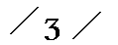  chat -   get -   pet - 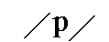  run -   vet -   win -   sing -   zen -  | Vowels  bait -   father -   bat -   wear -   beer -   feet -   bird -   wet - 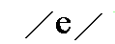  bite -   boat -   food -   foot -   hot - 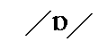  bought -   about -   boy -   hut -   pig -   apply / computer -   pure - 

