Look at each picture and its word. Fill in the missing letter.
  1.
    
    skyscr___per
  2.
    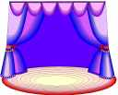
    stag___
  3.
    
    microsc___pe
  4.
    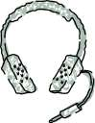
    headphon___s
  5.
    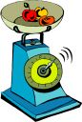
    ___cale
  6.
    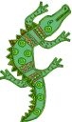
    croc___dile
  7.
    
    aprico___
  8.
    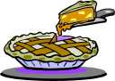
    p___e
  9.
    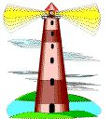
    lighth___use
  10.
    
    p___nda
  11.
    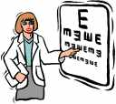
    opticia___
  12.
    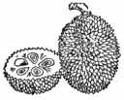
    ___urian
  13.
    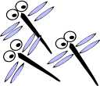
    dr___gonfly
  14.
    
    waf___le
  15.
    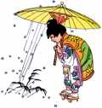
    ha___l
  16.
    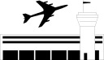
    airpo___t

