Look at each picture and its word. Fill in the missing letter.
  1.
    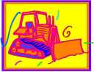
    bulldoze___
  2.
    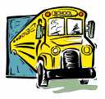
    b___s
  3.
    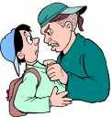
    b___lly
  4.
    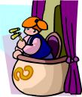
    balco___y
  5.
    
    bl___use
  6.
    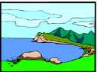
    ba___
  7.
    
    bol___
  8.
    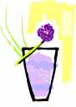
    blackbe___ry
  9.
    
    bub___le
  10.
    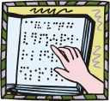
    brai___le
  11.
    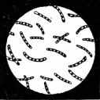
    b___cteria
  12.
    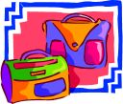
    b___g
  13.
    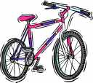
    bic___cle
  14.
    
    but___her
  15.
    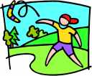
    boomera___g
  16.
    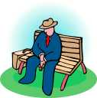
    benc___

