Look at each picture and its word. Fill in the missing letter.
  1.
    
    fe___r
  2.
    fo___k
  3.
    
    fe___er
  4.
    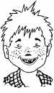
    f___eckle
  5.
    
    fa___ric
  6.
    
    f___ute
  7.
    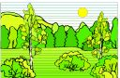
    f___rest
  8.
    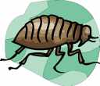
    f___ea
  9.
    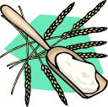
    flo___r
  10.
    
    f___rm
  11.
    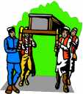
    funer___l
  12.
    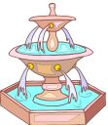
    fou___tain
  13.
    
    fossi___
  14.
    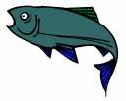
    fi___h
  15.
    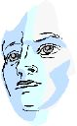
    fa___e
  16.
    
    f___ower

