Look at each picture and its word. Fill in the missing letter.
  1.
    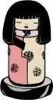
    dol___
  2.
    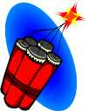
    dyn___mite
  3.
    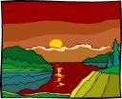
    du___k
  4.
    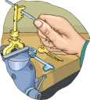
    dup___icate
  5.
    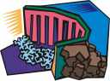
    d___m
  6.
    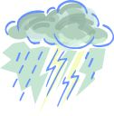
    dow___pour
  7.
    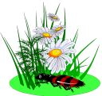
    d___isy
  8.
    
    d___ndelion
  9.
    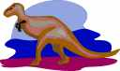
    dinosau___
  10.
    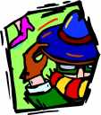
    di___guise
  11.
    
    d___nation
  12.
    
    do___phin
  13.
    
    direc___ion
  14.
    
    die___
  15.
    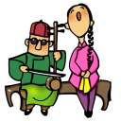
    du___t
  16.
    
    d___tergent

